Congratulations! Your child has been selected to represent < SCHOOL NAME> at the Regional Battle of the Books competition.

The regional battle will take place at <LOCATION> in < CITY> on <DATE>. The team will meet me at the high school at <REGISTRATION TIME> for registration. The actual battles will take place between <BATTLE START TIME> and <BATTLE END TIME>.

<SCHOOL> will NOT be providing transportation to these battles. It is the responsibility of the participant and their family to arrange for transportation to each battle.

If you have any questions about the Regional Battle of the Books competition, please visit http://www.oregonbattleofthebooks.org or contact me at the school.

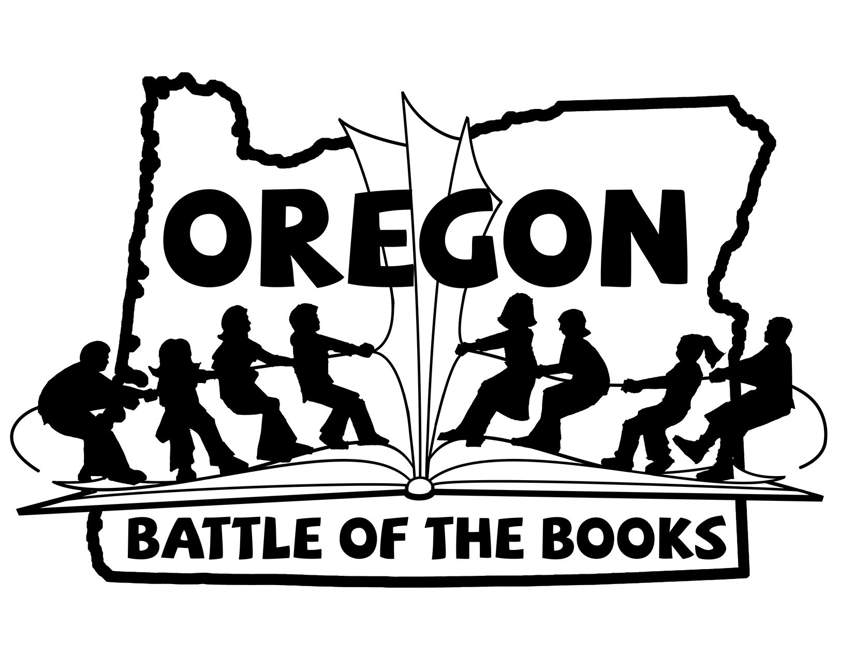
Thank you,

<NAME>
<TITLE/POSITION>

--------------------------------------------------------------------------------------------

Please return this form to <LIBRARIAN> in the library no later than

___________________________________ .

Student Name _________________________________________________

_____ Yes, my child has permission to compete in the Regional Battle of the Books Competition at ______________ on <DATE>. I agree to provide transportation to and from this event for my child.

_____ No, my child will not be competing in the Regional Battle of the Books competition

Parent Signature_______________________________ Date ____________

Contact Phone Number __________________________________________

